Reading this paper:

[Dense Text-to-Image Generation with Attention Modulation](https://arxiv.org/pdf/2308.12964:)

<https://arxiv.org/pdf/2303.18181>

Evaluation: <https://github.com/naver-ai/DenseDiffusion/issues/16>

Potential idea: Do ideal hyper parameters change based on different type of inputs (aka a theme) and can we quantify these differences and adjust hyper parameters based on the input?

## **Notes**:

* Many text-to-image models tend to be able to see fine details in text prompts that are very dense (example: specified colors and specific details will be ignored)
* DenseDiffusion is adapted (training free) to a pretrained text-to-image model to help it make more precise images
* Dense - each phrase describes a specific image region
* Current / previous diffusion models are bad at spacial placing
* Training and fine tuning a model is expensive
* the layout of a generated image is significantly related to self-attention and cross-attention maps
* (cn, mn)^N, c is part of text segment and m is a binary map (aka true where pixels are correlated to cn and false otherwise maybe?)
* **QUESTION:** What is denoising?
* Paused at 3.1 Preliminaries - Diffusion models
* POTENTIAL THING TO LOOK INTO: Non markovian diffusion models
* Non markovian have less denoising steps
* In this paper they use 50 DDIM Denoising steps
* **QUESTION**: What are intermediate features and what are context features?
* Ans: Intermediate features are created during hidden layers and context feature are dependent on the raw input
* Text conditioned diffusion models form position in early stages and fine details such as colors in later stages
* Query - Key attention condition map tells use whether we should increase or decrease the attention score for a particular pair. If two tokens belong to the same segment their score will be positive and their attention will increase
* NOTE: Queries are related to intermediate features and keys are related to context features
* **QUESTION**: What are time steps
* Each time step adds more noise? Going forward is more noise, going backwards is less noise
* 𝝀t represents the degree of modulation. We make less changes the smaller it is
* 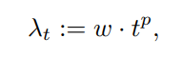
* t represents the time step
* In the cross attention layers the intermediate image features are updated according to the textual features
* The degree and location for how intermediate image features are update is effected by the attention scores between the image and text tokens. This is why the approach aims to update the attention score of certain text features in certain regions
* Self attention layers allow intermediate features to interact with each other to create a globally coherent result
* Goal in this paper is to restrict intermediate features from different segments to interact
* To prevent image quality from decreasing too much we want to create a way to modulate values only by a little bit
* Adjustment is proportional to the range between the max positive pair and the max negative pair
* One evaluation metric is CLIP: distance between input textual features and generate image features
* SOA-I Score checks if mentioned image object are in the image
* Dense diffusion is more accurate in reflecting layout conditions
* Spa-Text and MAS are training fine tuners which try to add in better generations with dense text
* What does it mean for a layer to be course

Experament idea:

Try to find ideal hyper features

* Use CLIP Score and SOA-I score to evaluate model at different hyper features
* Design a human based study to try to decide which metric works the best
* Design one subset to test for fidelity of image and the other subset to evaluate the image quality
* Stable diffusion will be the baseline, another option will be the hyper parameters the paper chose: p=5, wc = 1, ws = 0.3. **QUESTION:** How should I choose the other hyper parameters to test?

Parameters to test:

Baseline: m=1, wc=1, ws=0.3

Tweak m:

* m = 0.25
* m = 0.5
* m = 0.75

Tweak wc :

* wc =0.4
* wc = 0.8
* wc = 1.3

Tweak ws:

* ws = 0.1
* ws = 0.5
* ws = 0.7

http://127.0.0.1:7860/

Potential prompts:

Descriptive subject ____ Extra description of subject _____ doing something _____ specific location

A red clownfish with a tuxedo jumping towards the blue moon in space (UR)

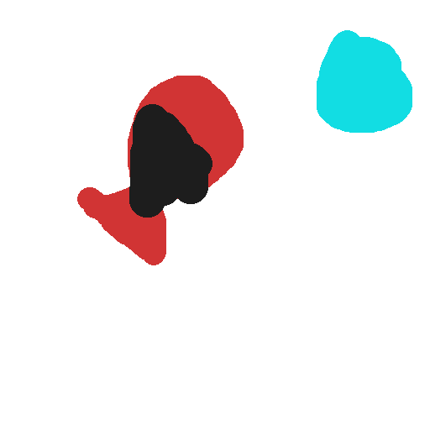

Baseline: m=1, wc=1, ws=0.3

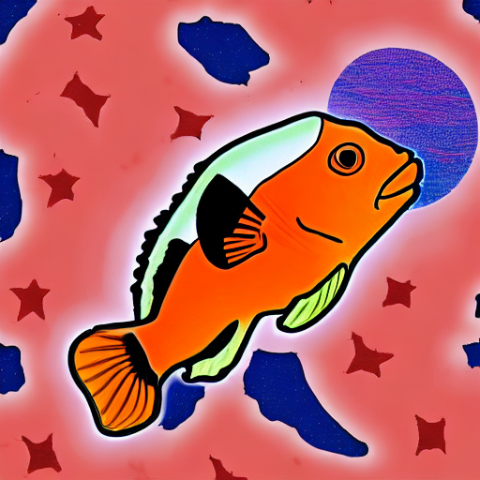

Tweak m:

* m = 0.25

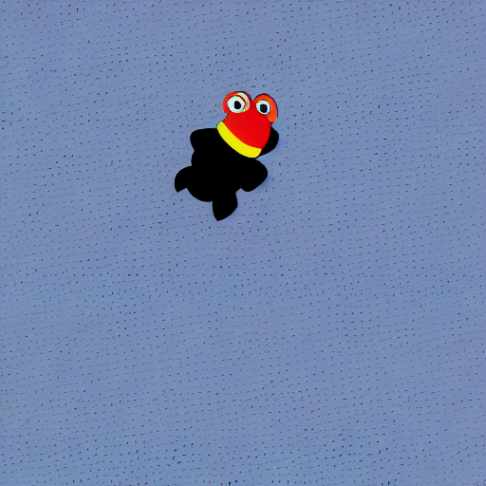

* m = 0.5

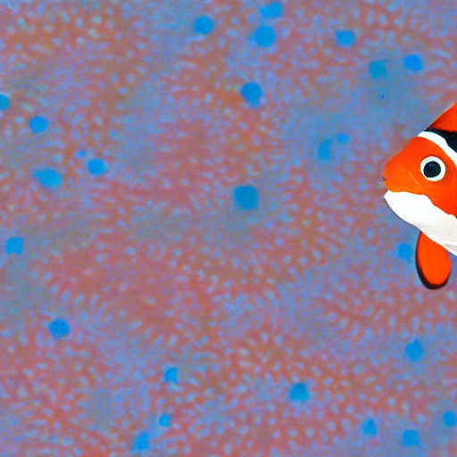

* m = 0.75

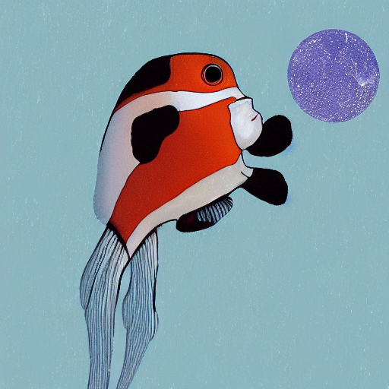

* m = 0.88

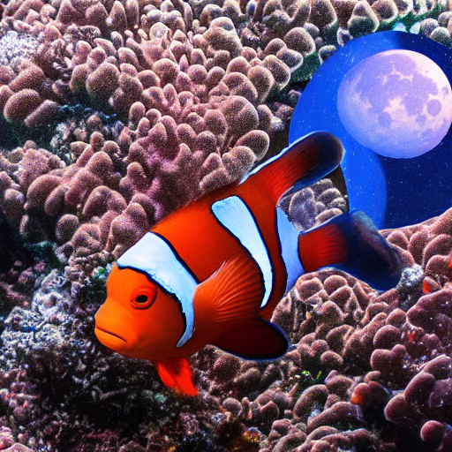

Tweak wc :

* wc =0.4

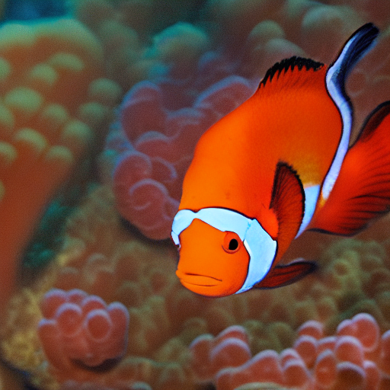

* wc = 0.8

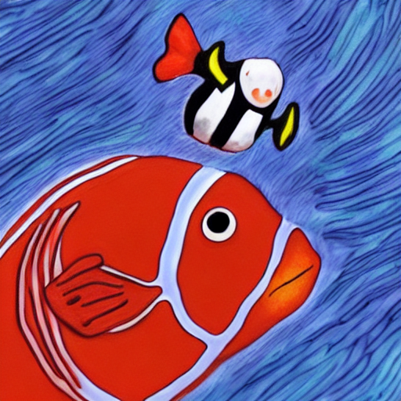

* wc = 1.3

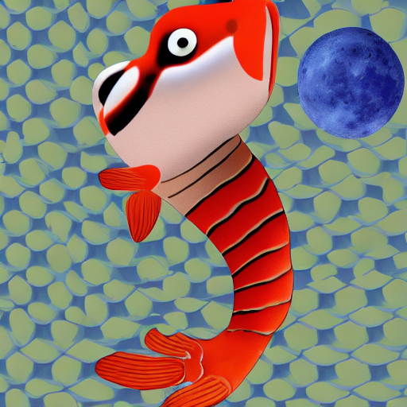

Tweak ws:

* ws = 0.1

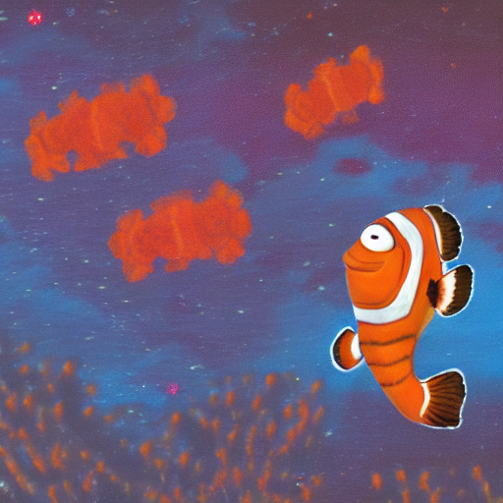

* ws = 0.5

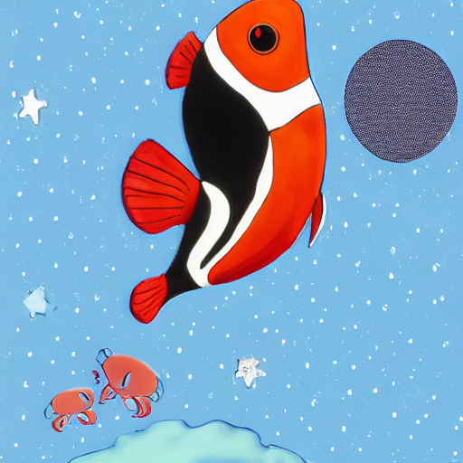

* ws = 0.7

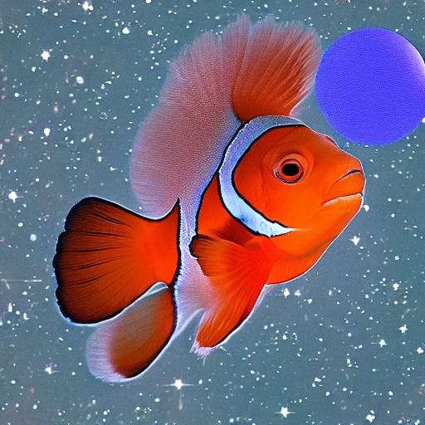

A man with long hear wearing a jacket singing in a highschool classroom (R)

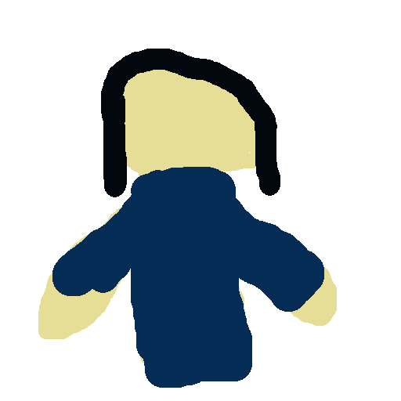

Baseline: m=1, wc=1, ws=0.3

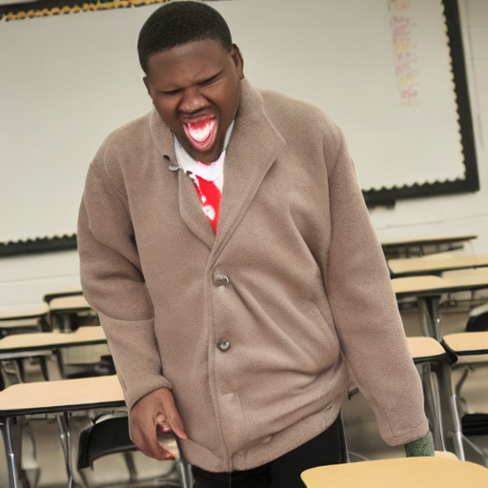

Tweak m:

* m = 0.25

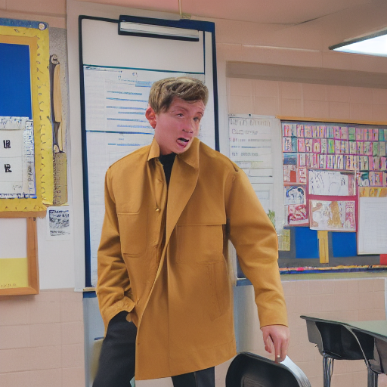

* m = 0.5

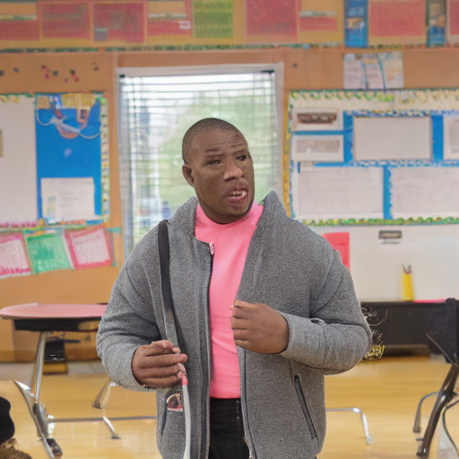

* m = 0.75

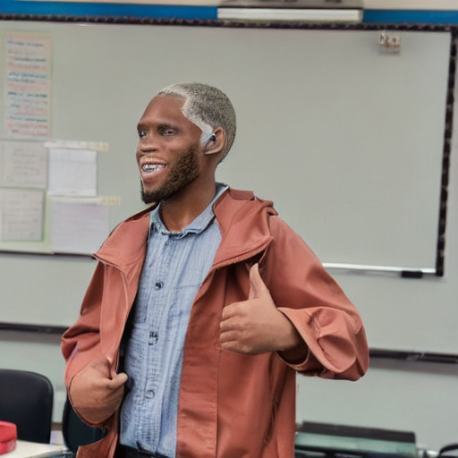

Tweak wc :

* wc =0.4

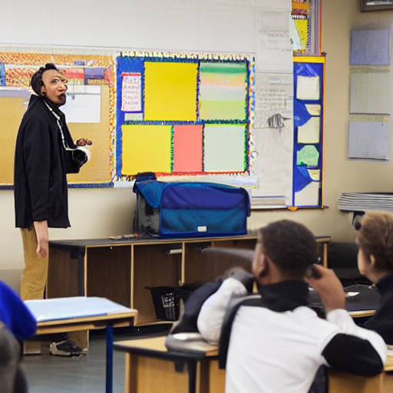

* wc = 0.8

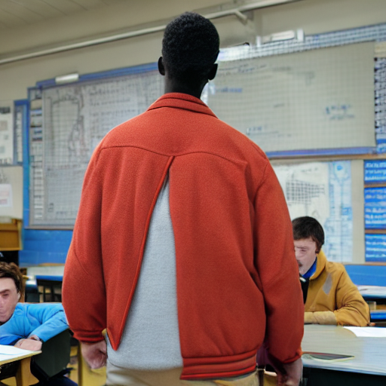

* wc = 1.3

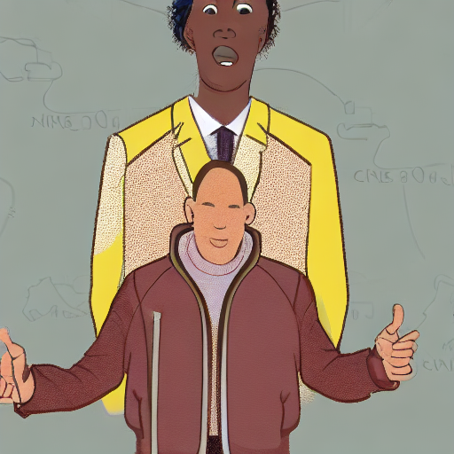

Tweak ws:

* ws = 0.1

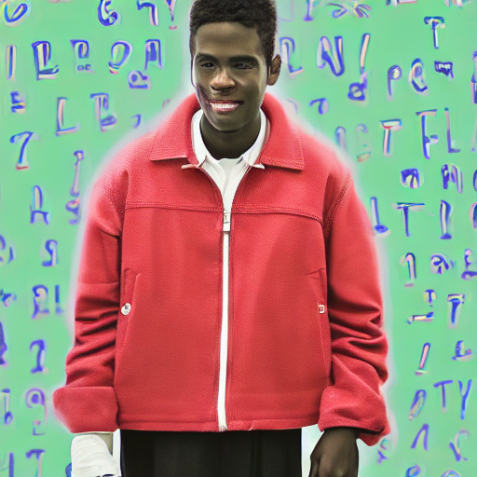

* ws = 0.5

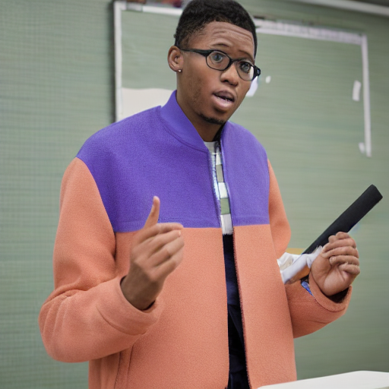

* ws = 0.7

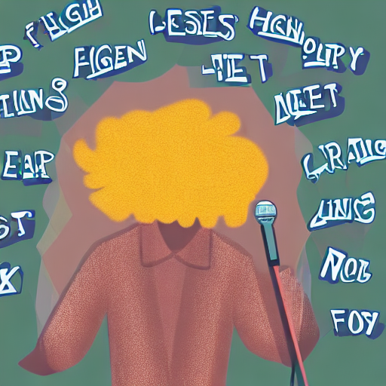

A zebra with wings on a skateboard skating at a commercial gym (UR)

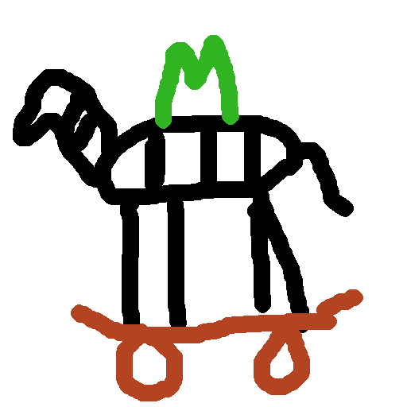

Baseline: m=1, wc=1, ws=0.3

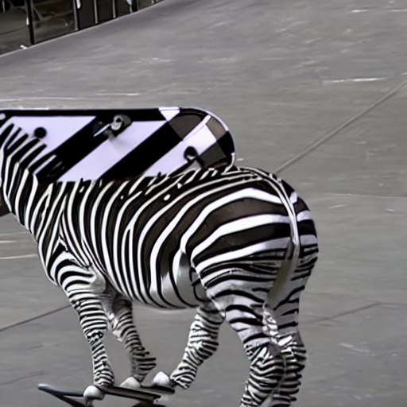

Tweak m:

* m = 0.25

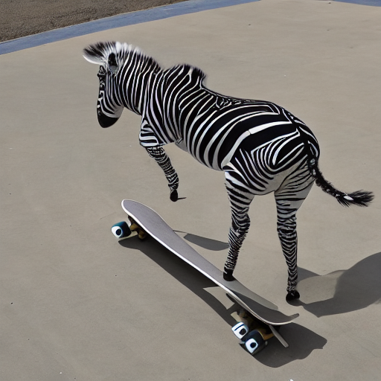

* m = 0.5

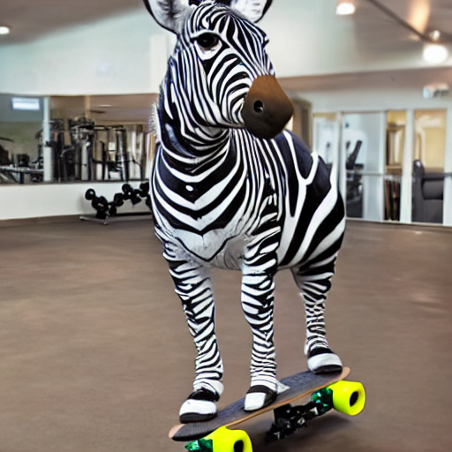

* m = 0.75

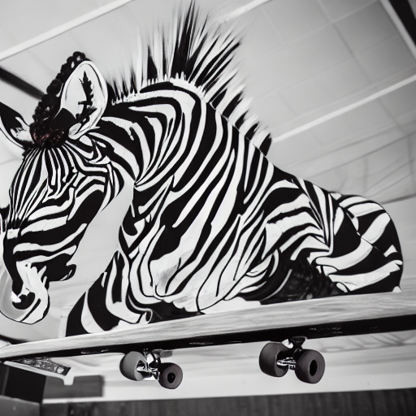

Tweak wc :

* wc =0.4

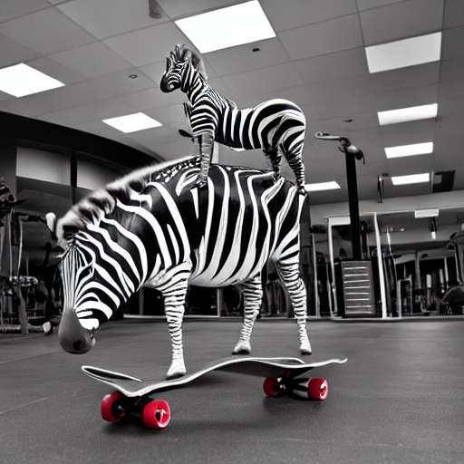

* wc = 0.8

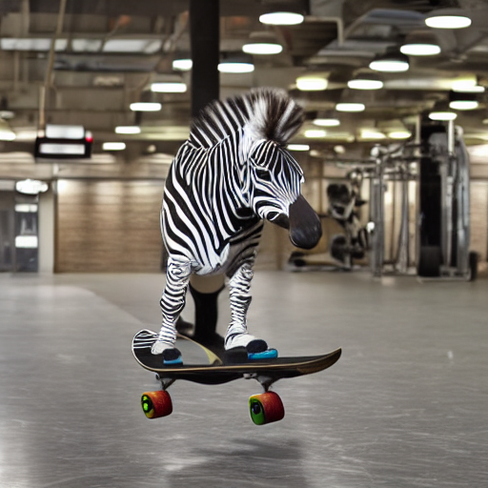

* wc = 1.3

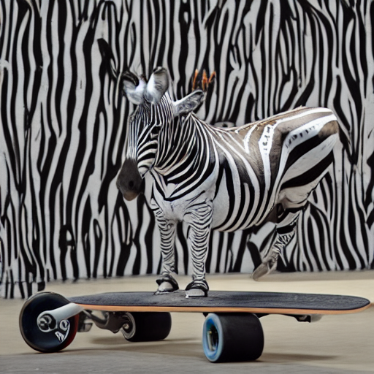

Tweak ws:

* ws = 0.1

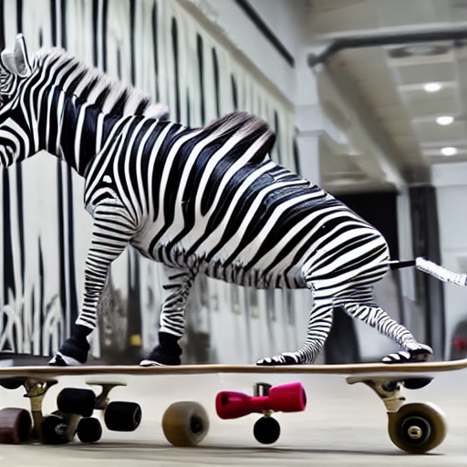

* ws = 0.5

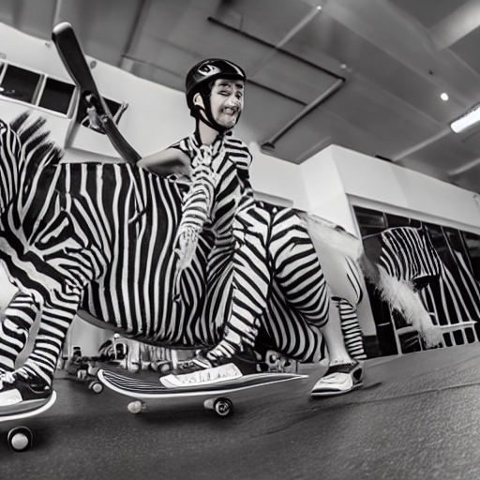

* ws = 0.7

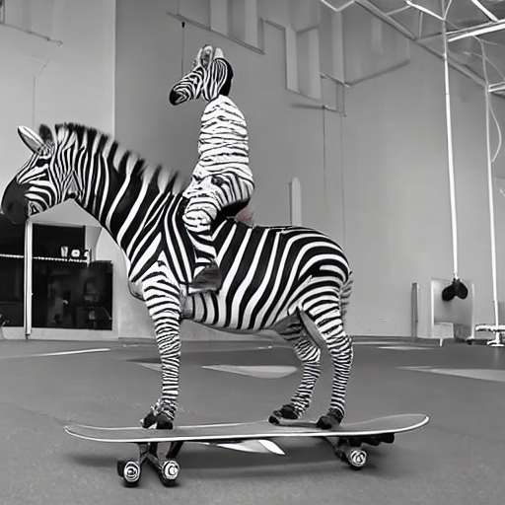

Round 2

Tweak m:

* M = 0.33
* M = 0.41

Tweak wc:

* Wc = 0.9
* Wc = 1.15

Tweak ws

* Ws = 0.4
* Ws = 0.6

### Clown Fish:

Round 2

Tweak m:

* M = 0.33

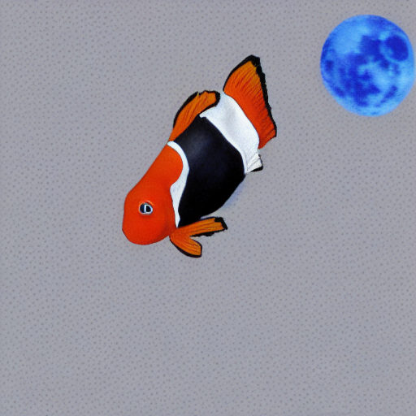

* M = 0.41

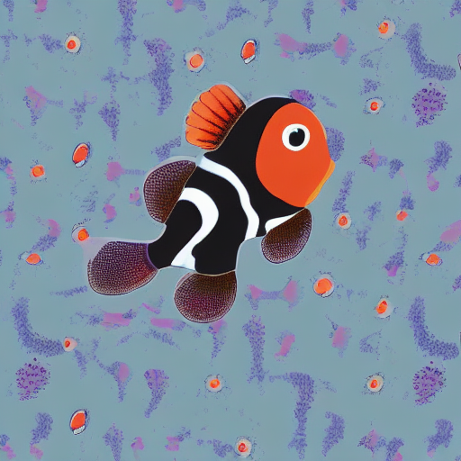

Tweak wc:

* Wc = 0.9

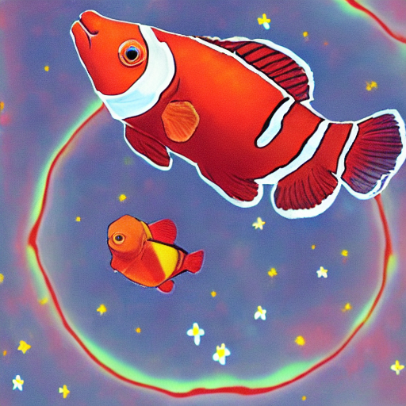

* Wc = 1.15

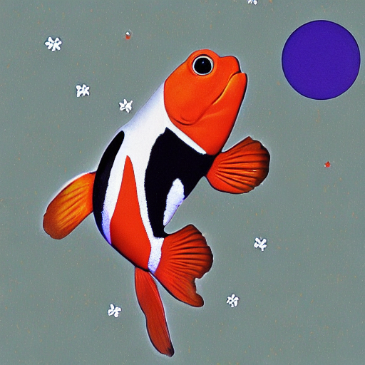

Tweak ws

* Ws = 0.4

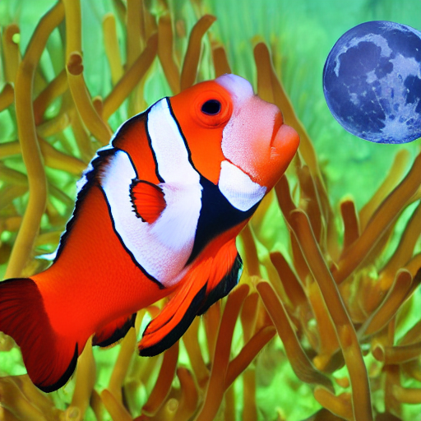

* Ws = 0.6

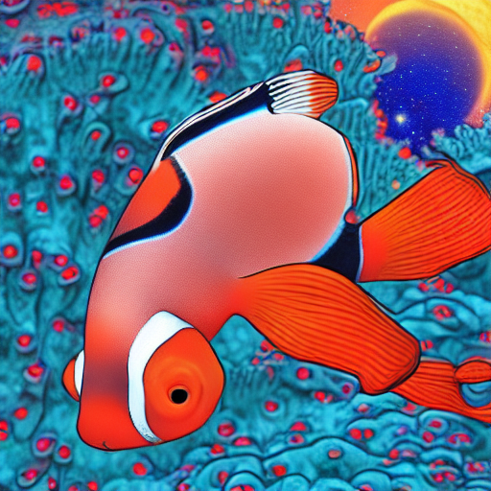

Long hair man

Tweak m:

* M = 0.33

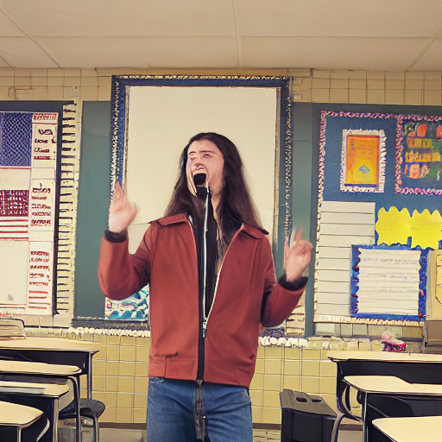

* M = 0.41

Tweak wc:

* Wc = 0.9
* Wc = 1.15

Tweak ws

* Ws = 0.4
* Ws = 0.6

A white fluffy dog wearing a pink bowtie and stealing a piece of bread at the park (R)

VSD

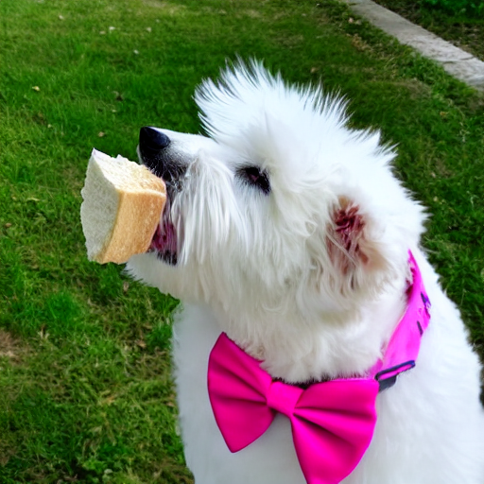

A purple ant wearing a pink bowtie and stealing a piece of bread at the park (UR)

A sweaty man sitting with a girl, while they paint in a park by the beach (R)